AI Assignment-04

Jeetu Mehra
U24AI032

Question 1 : Use the city map given in Q1 of assignment 1 and implement the best first search algorithm to reach your destination and compare your results in terms of the number of possible paths explored.
Code:
import heapq

# City map (Graph)
graph = {
"Syracuse": [("Buffalo",150), ("New York",254), ("Boston",312)],
"Buffalo": [("Syracuse",150), ("Detroit",256), ("Cleveland",189)],
"Detroit": [("Buffalo",256), ("Chicago",283)],
"Chicago": [("Detroit",283), ("Cleveland",345), ("Indianapolis",182)],
"Cleveland": [("Chicago",345), ("Buffalo",189), ("Columbus",144), ("Pittsburgh",134)],
"Indianapolis": [("Chicago",182), ("Columbus",176)],
"Columbus": [("Indianapolis",176), ("Cleveland",144), ("Pittsburgh",185)],
"Pittsburgh": [("Cleveland",134), ("Columbus",185), ("Baltimore",247), ("New York",305)],
"Baltimore": [("Pittsburgh",247), ("Philadelphia",101)],
"Philadelphia": [("Baltimore",101), ("New York",97)],
"New York": [("Philadelphia",97), ("Pittsburgh",305), ("Boston",215)],
"Boston": [("New York",215), ("Providence",50), ("Portland",107)],
"Providence": [("Boston",50)],
"Portland": [("Boston",107)]
}

# Heuristic values (estimated closeness to Chicago)
heuristic = {
"Chicago": 0,
"Detroit": 1,
"Cleveland": 2,
"Buffalo": 3,
"Indianapolis": 3,
"Columbus": 4,
"Pittsburgh": 5,
"Syracuse": 6,
"Baltimore": 7,
"Philadelphia": 8,
"New York": 9,
"Boston": 10,
"Providence": 11,
"Portland": 12
}

# Best-First Search Algorithm
def best_first_search(start, goal):
priority_queue = []
heapq.heappush(priority_queue, (heuristic[start], start, [start]))
visited = set()
paths_explored = 0

while priority_queue:
h, current, path = heapq.heappop(priority_queue)
paths_explored += 1

print(f"Expanding: {current} | Heuristic: {h}")

if current == goal:
print("\nGoal Reached!")
return path, paths_explored

visited.add(current)

for neighbor, cost in graph[current]:
if neighbor not in visited:
heapq.heappush(
priority_queue,
(heuristic[neighbor], neighbor, path + [neighbor])
)

return None, paths_explored

# -------- MAIN --------
start_city = "Syracuse"
goal_city = "Chicago"

path, explored = best_first_search(start_city, goal_city)

print("\nFinal Path:", " → ".join(path))
print("Total Paths Explored:", explored)

Output:
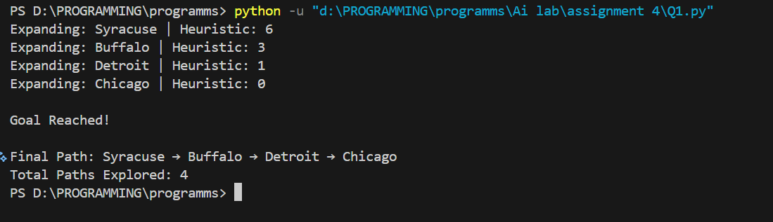

Question 2 : Consider a building floor plan as given in figure. Design a robot guided evacuation planning using the best first search algorithm. Consider the following constraints:
- Allowed movements up, down, left and right
- Walls and rooms block movement
- Evacuation planning covers the route from entry to exit
- Design an evaluation cost function with proper justification for your algorithm
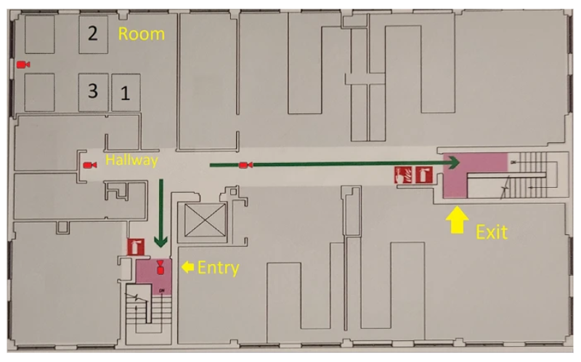
Code:
import heapq

# -------------------------------
# Floor Plan Grid
# 0 = Walkable Path
# 1 = Wall / Blocked
# -------------------------------
grid = [
[1, 1, 1, 1, 1, 1, 1, 1, 1, 1, 1, 1, 1, 1, 1, 1, 1, 1, 1, 1],
[1, 0, 0, 1, 0, 0, 1, 1, 1, 1, 0, 0, 1, 0, 0, 1, 0, 0, 0, 1],
[1, 0, 0, 1, 0, 0, 1, 1, 1, 1, 0, 0, 1, 0, 0, 1, 0, 0, 0, 1],
[1, 1, 1, 1, 1, 1, 1, 1, 1, 1, 0, 0, 1, 1, 1, 1, 1, 1, 1, 1],
[1, 0, 0, 0, 0, 0, 0, 0, 0, 0, 0, 0, 0, 0, 0, 0, 0, 0, 0, 0],
[1, 1, 1, 0, 1, 1, 1, 1, 0, 0, 1, 1, 0, 0, 0, 1, 1, 1, 1, 1],
[1, 0, 0, 0, 0, 0, 0, 1, 0, 0, 1, 1, 0, 0, 0, 1, 0, 0, 0, 1],
[1, 1, 1, 1, 0, 0, 0, 1, 0, 0, 1, 1, 0, 0, 0, 1, 0, 0, 0, 1],
[1, 0, 0, 1, 0, 0, 0, 1, 1, 1, 1, 1, 1, 1, 1, 1, 1, 1, 1, 1],
[1, 1, 1, 1, 1, 1, 1, 1, 1, 1, 1, 1, 1, 1, 1, 1, 1, 1, 1, 1]
]

rows = len(grid)
cols = len(grid[0])

# Entry and Exit Points
START = (8, 4)
GOAL = (4, 18)

# -------------------------------
# Heuristic Function (Manhattan Distance)
# h(n) = |x1-x2| + |y1-y2|
# -------------------------------
def heuristic(current, goal):
return abs(current[0] - goal[0]) + abs(current[1] - goal[1])

# -------------------------------
# Best First Search Algorithm
# f(n) = h(n)
# -------------------------------
def best_first_search(grid, start, goal):
pq = []
heapq.heappush(pq, (heuristic(start, goal), start))

visited = set()
visited.add(start)

parent = {}
parent[start] = None

explored = 0

while pq:
h, current = heapq.heappop(pq)
explored += 1

# Goal check
if current == goal:
return parent, explored

r, c = current

# Possible Moves: Up, Down, Left, Right
moves = [(-1,0), (1,0), (0,-1), (0,1)]

for dr, dc in moves:
nr, nc = r + dr, c + dc
new_state = (nr, nc)

# Check boundaries and wall
if 0 <= nr < rows and 0 <= nc < cols and grid[nr][nc] == 0:
if new_state not in visited:
visited.add(new_state)
parent[new_state] = current
heapq.heappush(pq, (heuristic(new_state, goal), new_state))

return None, explored

# -------------------------------
# Path Reconstruction
# -------------------------------
def get_path(parent, start, goal):
path = []
curr = goal

while curr is not None:
path.append(curr)
curr = parent[curr]

path.reverse()
return path

# -------------------------------
# Print Grid with Path
# -------------------------------
def print_grid(grid, path):
path_set = set(path)

print("\nGrid Path Output:\n")
for r in range(rows):
for c in range(cols):
if (r, c) == START:
print("S", end=" ")
elif (r, c) == GOAL:
print("E", end=" ")
elif (r, c) in path_set:
print(".", end=" ")
elif grid[r][c] == 1:
print("#", end=" ")
else:
print(" ", end=" ")
print()

# -------------------------------
# MAIN
# -------------------------------
print("Starting Robot Evacuation Planning using Best First Search...")
print("Start =", START)
print("Goal =", GOAL)

parent, explored = best_first_search(grid, START, GOAL)

if parent:
path = get_path(parent, START, GOAL)

print("\n✅ Goal Found!")
print("Path Length =", len(path))
print("Nodes Explored =", explored)
print("Path =", path)

print_grid(grid, path)

print("\nEvaluation Function:")
print("f(n) = h(n)")
print("h(n) = Manhattan Distance = |x1-x2| + |y1-y2|")

else:
print("\n No path found!")

Output:
